EBSCO module for Drupal 8

# Description

The EBSCO module adds the search capabilities of EBSCO Discover service to an existing Drupal 7 installation.

# Features

The module implements 3 pages :

* Results page
* Result page
* Advanced Search page

and 1 blocks :

* EBSCO Discovery Service

The search capabilities include filters like facets, limiters, expanders, search modes and page options .

# Installation

The EBSCO module can be installed like this:

4.1 Upload ebsco-drupal.zip to your Drupal sites/all/modules directory

4.2 Unpack ebsco-drupal.zip, it should create the sites/all/modules/ebsco directory

4.3 Login as administrator and go to “Modules”, you should see the “EBSCO Discovery Service” module in the “Others” list of modules

4.4 Check the “ENABLED” checkbox and then press the “Save configuration” button

After the page was refreshed you should see the “Help”, “Permissions” and “Configure” links next to “EBSCO Discovery Service”, just like in the following screenshot :

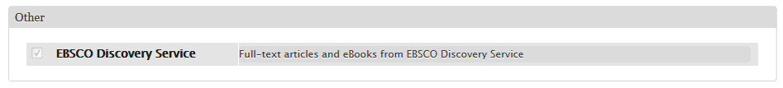

4.5 Follow the “Configure” link and fill in the requested fields in the “EBSCO settings” form : 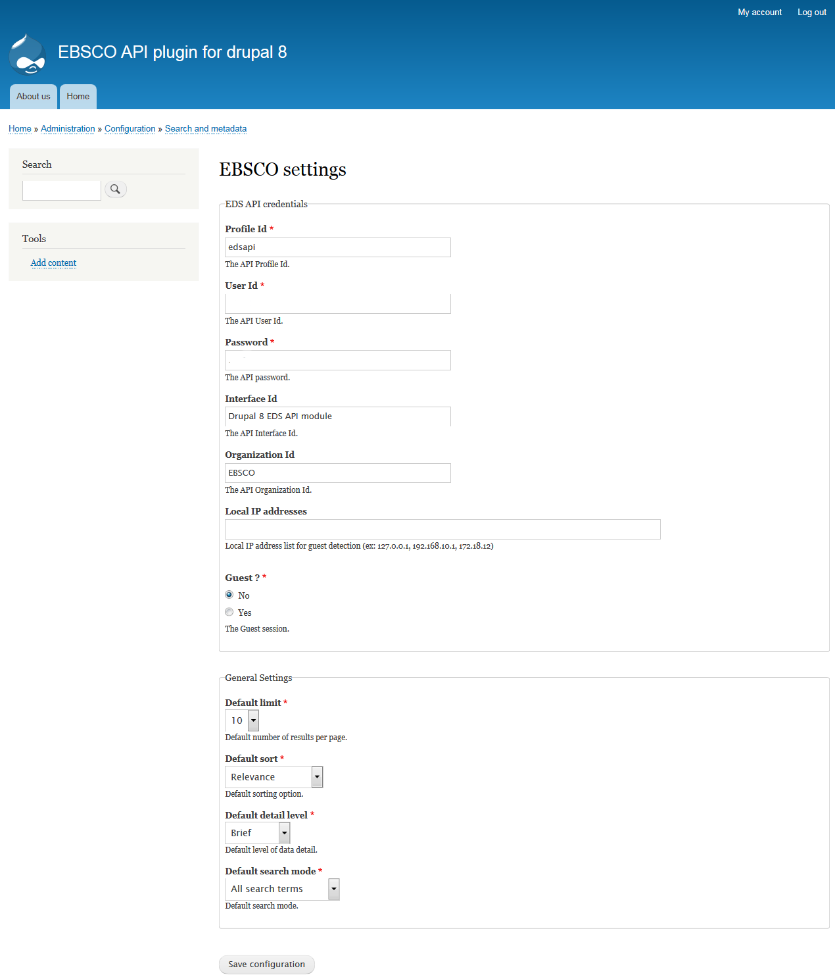

4.6 Go to Drupal “Structure” menu, then go to “Block Layout” and you will notice one block : “EBSCO Discovery Service”.

You can setup the module like in the following screenshot :

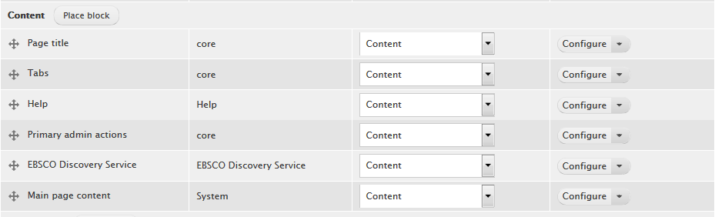

In the above screenshot the “EBSCO Search Form” block will be embedded in the content of the page

This configuration is best suited for displaying the EBSCO module UI.

Press “Save blocks” button in order to submit the changes.

These are all the steps required to install the EBSCO module.

If you logout and go to Home page then you should see something like the following screenshot :

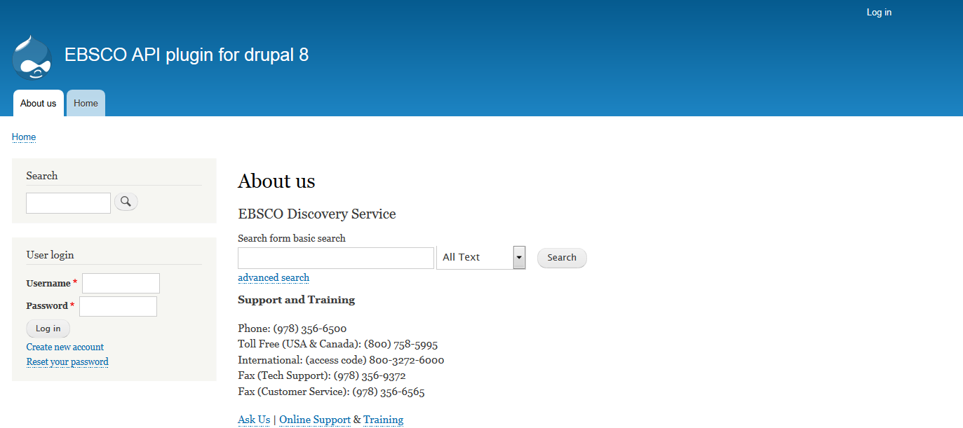

In the above screenshot you can see the basic search form at the top of the content .

# Design

The module is using only the Drupal 8 core , it’s not dependent on other modules.

The module is using PHP 5.3, like Drupal 8.4.4, so you don’ t have to install or update anything else.

The module is using the PHP session for storing various internal data.

The module was implemented using a default Drupal 8.4.4 installation, with Bartik theme.

The “EBSCO Search Form” blocks is visible for some pages and are hidden for others, the visibility is hard coded in the module’s code. E.g. “EBSCO Search Form” block is not visible on EBSCO advanced search page .

Appendix A

The list of EBSCO module files :

Files EBSCOAPI.php, EBSCOConnector.php, EBSCOResponse.php and sanitizer.class.php are used for performing EDS API requests. They are pretty much independent from Drupal (except for using the Drupal HTTP client).

Files EBSCODocument.php and EBSCORecord.php are used for searching and displaying results, for displaying a single record, for performing an advanced search, etc. They are used in ebsco.module.

Appendix B

Screenshots with EBSCO module pages (Bartik as default theme) :

Empty search page:



Search page with results :

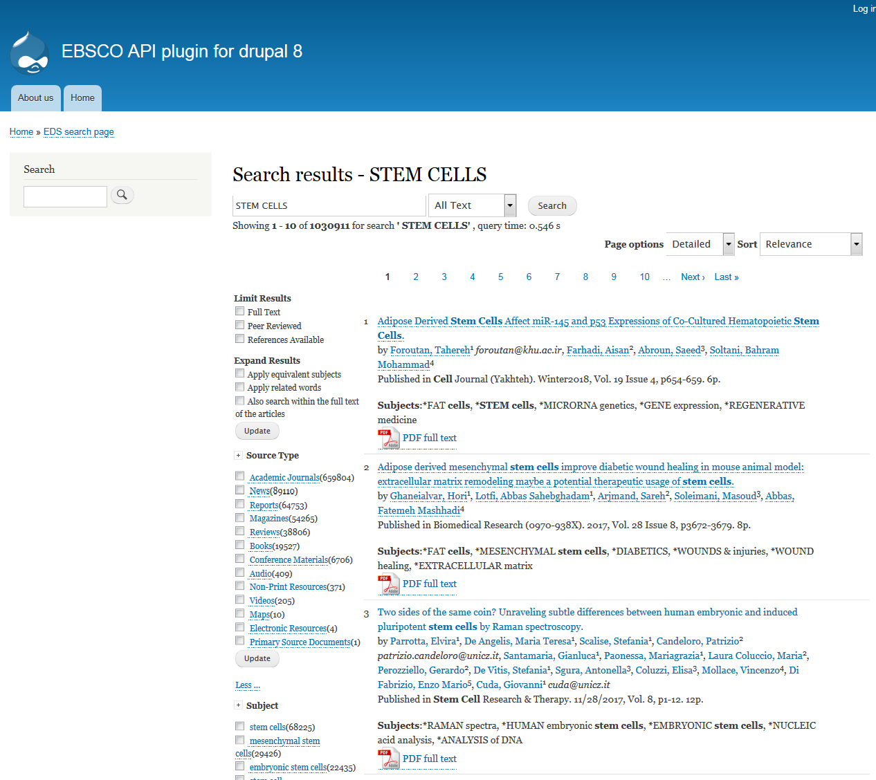

Result page :

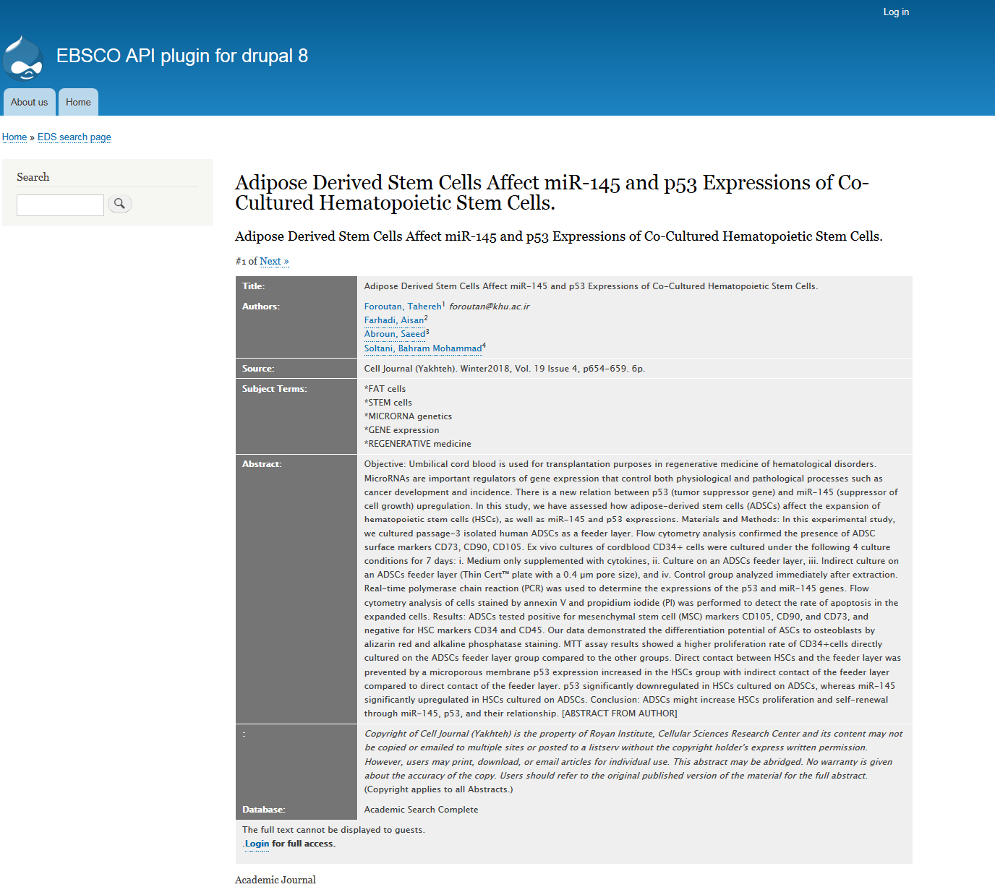

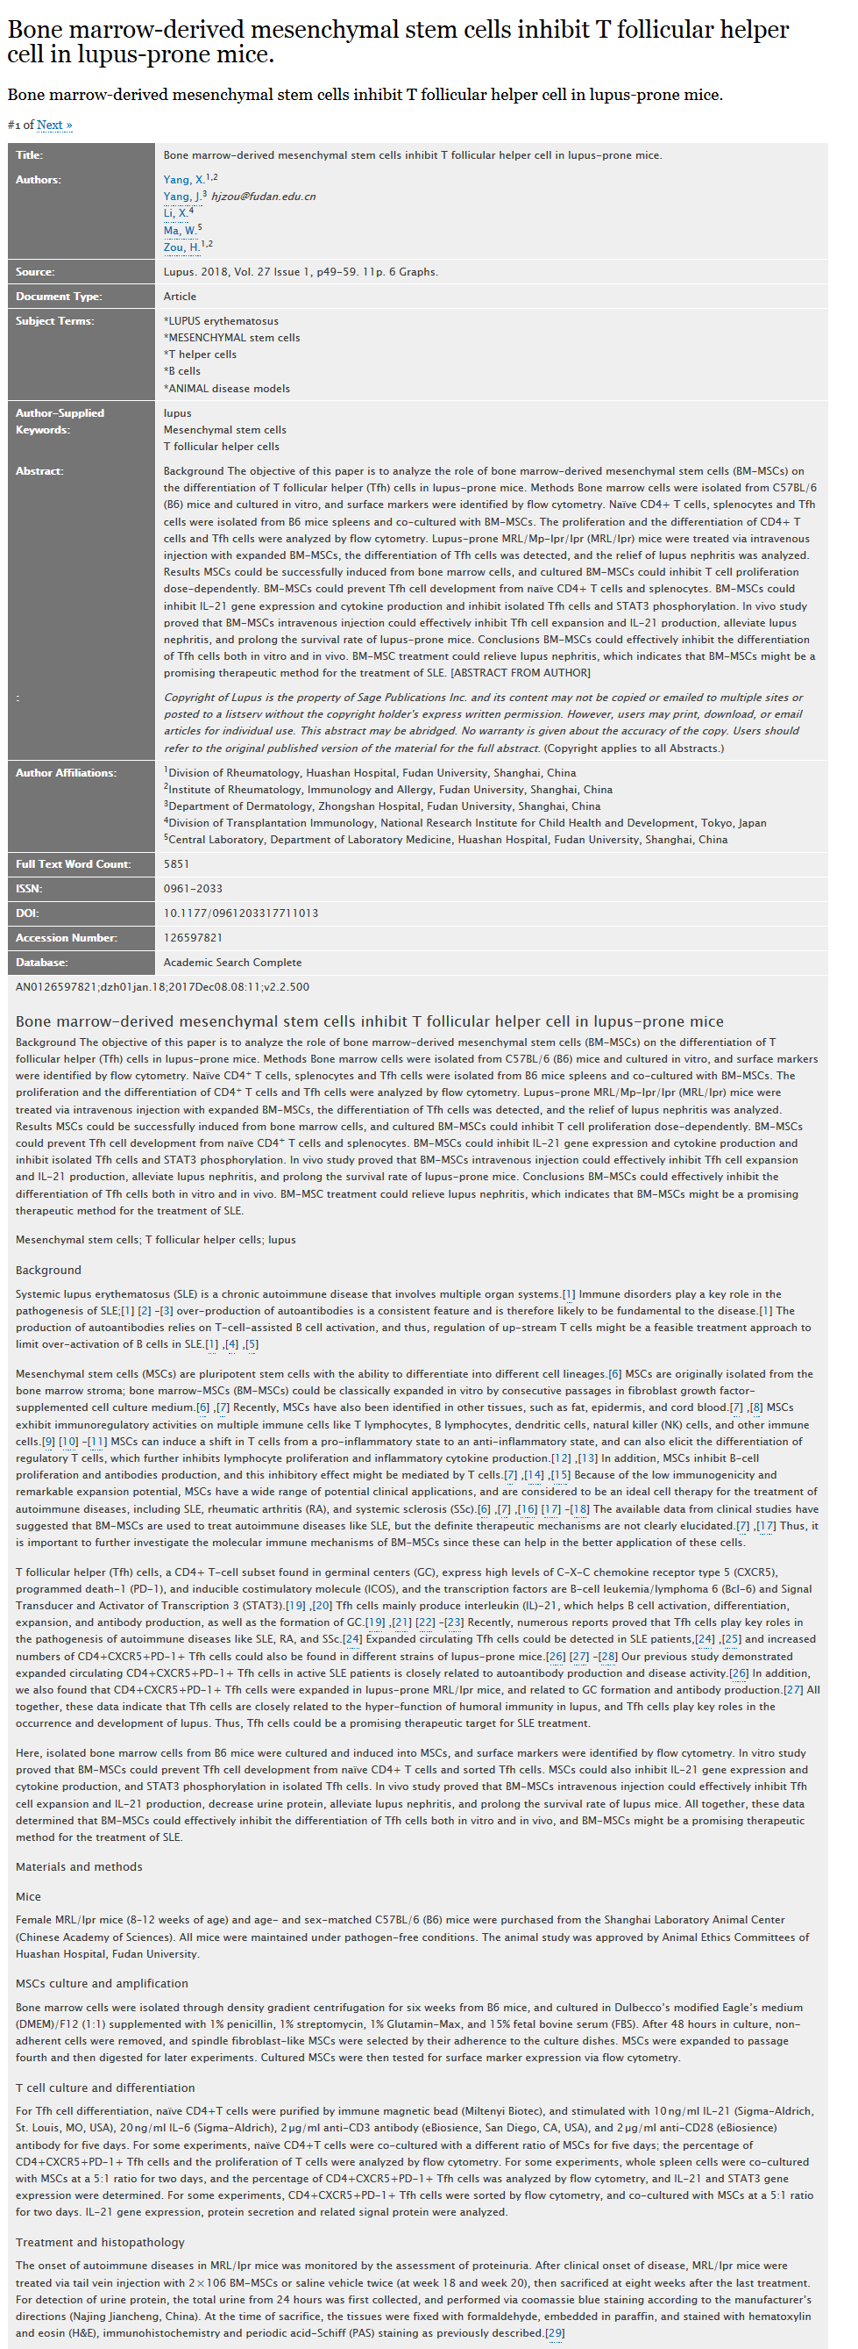HTML Full text page